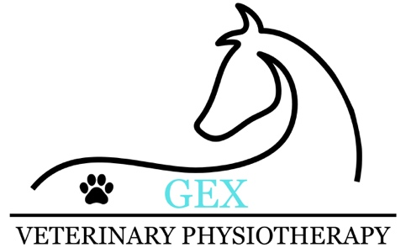
Terms and conditions (From June 2026)

- Veterinary Physiotherapists are obliged to treat under the Veterinary Surgeons act 1966 and Veterinary Surgeons (exemptions) order 2015 in which veterinary consent must be required when an animal has a diagnosed or undiagnosed condition. Therefore, an appropriately detailed and signed veterinary consent form from the animals registered vets and/or veterinary surgeon is required for treatment to commence.

However, veterinary consent is not required when an animal is deemed healthy (e.g. no new lameness) and only receiving treatment for maintenance purposes.

- You must keep GEX Veterinary Physiotherapy informed of any new medical attention that your animal has received (e.g. medication, investigations, conditions or changes in veterinary practice). A new veterinary consent may be required in some scenarios, however, GEX Veterinary Physiotherapy can discuss whether this is a requirement and can sought veterinary consent themselves if needed.

- You must take fully responsibility and be transparent in declaring/warning GEX Veterinary Physiotherapy towards known dangerous/harmful behaviours which the animal may present during treatment.

- GEX Veterinary Physiotherapy has the right to refuse to provide treatment if it is deemed that veterinary attention is required prior to treatment (e.g. new lameness during assessment) or if the animals presenting behaviours are a danger towards the physiotherapist.

- GEX Veterinary physiotherapy has the right to contact your animals veterinary surgeon to discuss your animal, including clinical findings, appropriate treatment plans and provide updates on your animals condition. GEX Veterinary Physiotherapy works in accordance with GDPR and will not share any information with third parties.

- Photos and videos may be taken during an animal treatment as a method of monitoring changes in your animals movement or condition. Only with prior permission from the owner, these photos and videos may be uploaded to GEX Veterinary Physiotherapy social pages including Instagram, Facebook and TikTok. As an owner you also have the right to take photos or record any parts of your animals treatment and share them if you wish.

- Cancellations are accepted and clients are not expected to pay for the appointment (and initial assessment deposits refunded) if they have provided more than 48 hours notice. However, if less than 48 hours notice is given then 50% of the appointment price is required. If less than 24 hours notice is given then clients are required to pay the full appointment price. This will be considered on an individual basis as we understand unprecedented circumstances can occur.

- A deposit is required to book your first appointment (initial assessment and treatment). This deposit is solely paid by bank transfer. For the remaining balance and for any other appointments the full balance can either be paid on the day by cash, bank transfer or via the card reader carried (physical card, contactless or apple/google pay). If you have trouble making payment via any of these methods GEX Veterinary Physiotherapy does allow bank transfer after the appointment when you regain signal/wifi, however, final balances are required to be paid within 48 hours. If payment is delayed, a 2% fee will be added onto your bill each day past the due date (invoice provided).

- If you are planning on claiming the treatment back on your insurance company, treatment sessions are still required to be paid at the time of the appointment and then claimed back from your insurer at a later date.

Requirements before a physiotherapy treatment:
- You must provide a suitable, safe and dry place for treatment to take place.
- Please ensure you and your animal are ready on time for your allocated appointment slot. If you are late to your own appointment, treatment will only commence once you have arrived and treatment will still cease at the dedicated time.
- Animals must be sufficiently clean (e.g. no/little mud) and dry (e.g. no/little sweat and rain) before the start of the treatment session.
- All owners must adequately restrain their animals during treatment and be able to sufficiently control their animals.

Statement
I have read, understood and agreed to the terms and conditions outlined above and will adhere to the specified information.

PRINT NAME:

DATE:

SIGNATURE:

